Appendix B: Publication Procedure Form


College of Business,
Technology and
Engineering

Research Skills and
Dissertation Module
(55-706556).

PUBLICATION PROCEDURE FORM
In this module, while you create your own research question or topic area, your supervisor makes a significant intellectual contribution to this work as the research progresses. Your supervisor will make the decision on whether your work merits publication based on the quality of the work you have produced. Your supervisor will co-author the paper for publication with you and your supervisor will both be listed as authors. You are required to sign the declaration below to confirm that you understand and will follow this procedure.
Declaration:
I Mandar Dnyaneshwar Satpute confirm that I understand will comply with the Publication Procedure outlined in the Module Handbook and the Blackboard Site.
G5
Student: | Signature  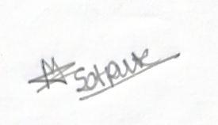 | Date  07/01/2026
Supervisor: | Signature 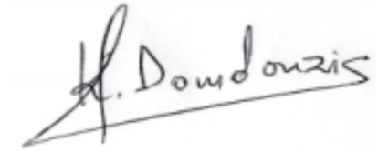 | Date  07/01/2026

